**Regression Analysis**

**Heatmap-**

**Goal 1-**

To maintain Ideal Room Temperature. Its factors are Outside Temperature, Relative Humidity and HVAC System.

**Room Temperature and Outside Temperature-**

**Y = 0.210062x + 17.184197**

**Room Temperature and Relative Humidity-**

**Y = 0.218328x + 12.393919**

**Room Temperature and Number of Occupants-**

**Y = 0.029248x + 21.344192**

**Room Temperature and HVAC Consumption-**

**Y = 0.002565x + 21.431008**

**Number of Occupants and HVAC Consumption-**

**Y = 0.0769x + 7.8548**

**Number of Occupants and Relative Humidity-**

**Y = 7.0689x – 286.69**

**Goal 2-**

To ensure the Energy Consumption and Energy Cost is within its limit. Its factors are HVAC System, Light System and Solar Irradiance.

**Energy Consumption and HVAC Consumption-**

**Y = 0.994367x + 114.000919**

**Energy Consumption and Light Consumption-**

**Y = 664.422544 - 3.704880x**

**Energy Consumption and Additional Equipment Consumption-**

**Y = 26.474994x + 227.543620**

**Energy Cost and HVAC Consumption-**

**Y = 0.0769x + 7.8548**

**Energy Cost and Light Consumption-**

**Y = 0.0007x + 0.1580 – 0.0008x**

**Energy Cost and Additional Equipment Consumption-**

**Y = 0.006047x + 0.059177**

**Coinciding Factors-**

**Number of Occupants and Additional Equipment Consumption-**

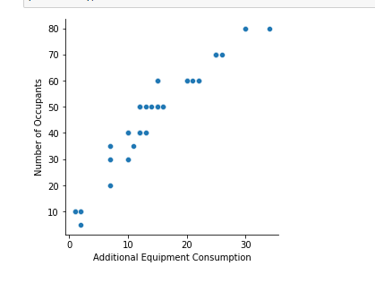**Y = 2.451671x + 11.501346**

**Light Consumption and Solar Irradiance-**

**Y = 62.404971 - 0.071158x**

**Conclusion-**

**Room Temperature and Energy Consumption-**

**Y = 0.0027x + 21.0891**

**Room Temperature and Energy Cost-**

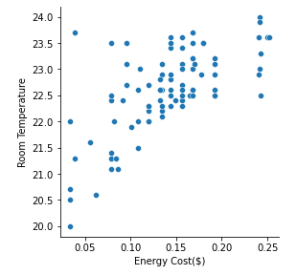**Y = 11.0220x + 21.0926**

**Number of Occupants and Energy Consumption-**

**Y = 0.0776x – 1.0859**

**Number of Occupants and Energy Cost-**

**Y = 321.002965 – 1.006503x**